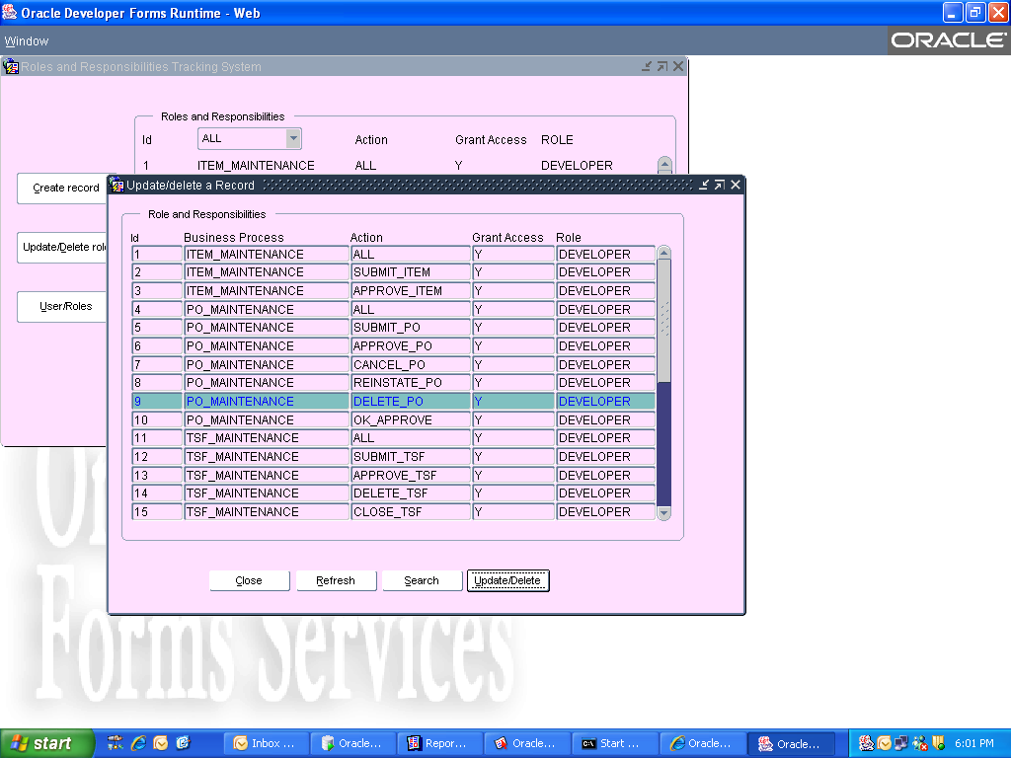

When I click update/delete button it will open below form…actually
The record (9,po_maintenance,delete_po,y,developer) needs to pass to the next form.
But its not happening.please help me
I wrote below code on the update/delete button…

declare

PARM_LIST PARAMLIST;
PL_ID varchar2(9):='rnr_view'; --where rnr_view is calling form

begin

-- destroy the parm list if still present
parm_list := get_parameter_list(pl_id);

if pl_id is not null then
DESTROY_PARAMETER_LIST(parm_list);
end if;
PARM_LIST := Create_Parameter_List(PL_ID);

-- add parameters
add_parameter(PARM_LIST,
'PM_ID',
TEXT_PARAMETER,
:b_header.id);

-- call the program
open_form('rnr_update', --rnr_update is called form
ACTIVATE,
SESSION,
PARM_LIST);

end;
