Image OK:

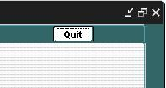

Bad Image (No Text on Quit Button):
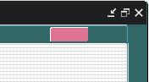

Buttons OK:

Buttons Showing Faded:

