CDR Tool information:

CDRT server machine’s specs.
The format is a bit different as machines are of different brands, on this machine, the hardware (CPU & RAM) specs are from within the OS

CPU details:
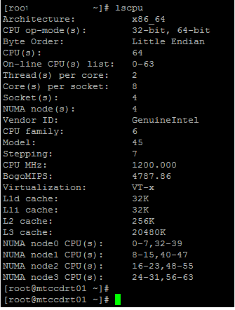

RAM details:
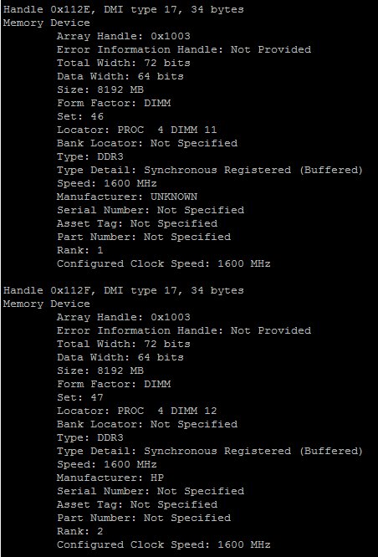
…cut…
- Number of populated memory banks: 32
- RAM modules capacity: 8192MB

OS version info:
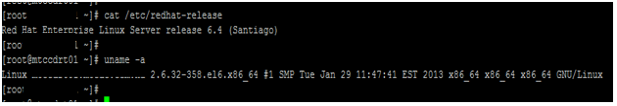

Oracle DB version info:
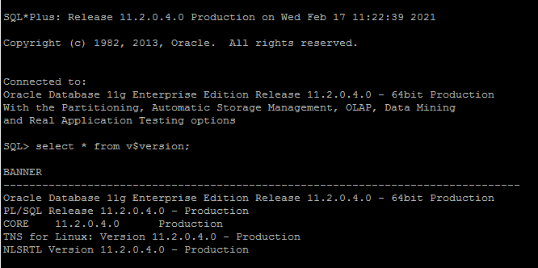

I have attached the NIC and storage usage stats

