LOV buttons do not show questioning, but ellipsis.

In forms builder appear the question mark
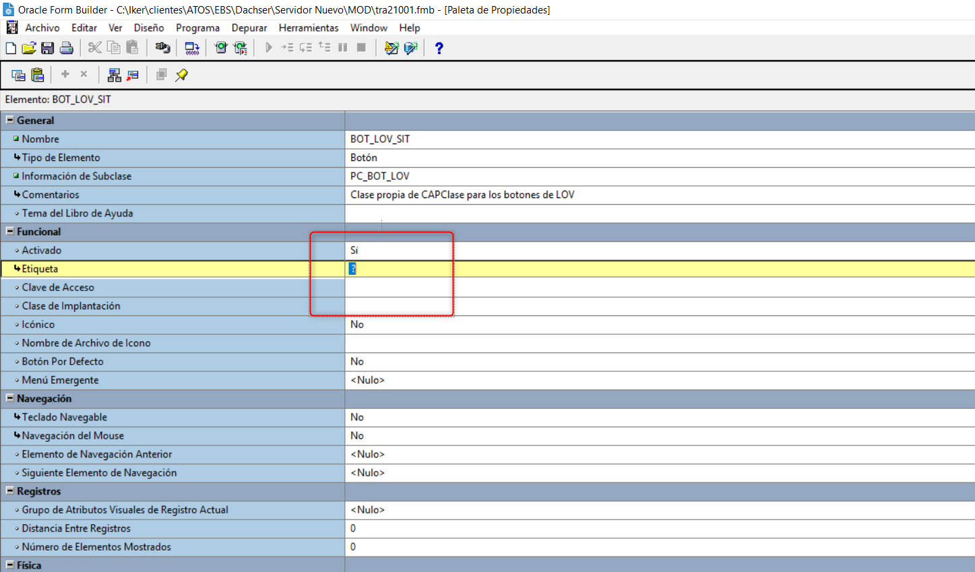

But in execution show ellipsis

