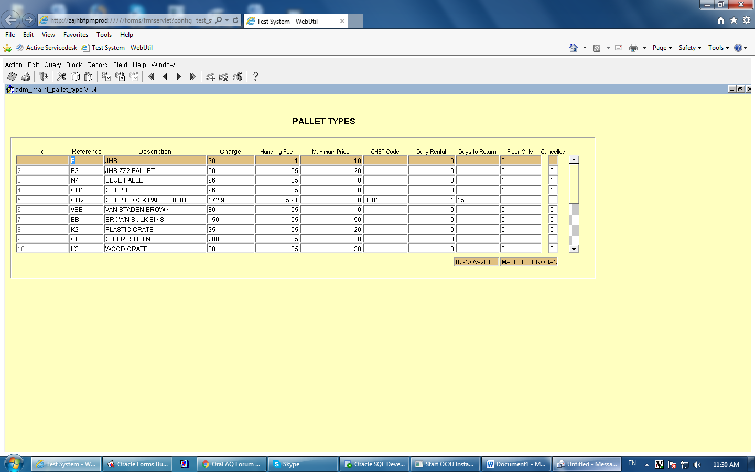
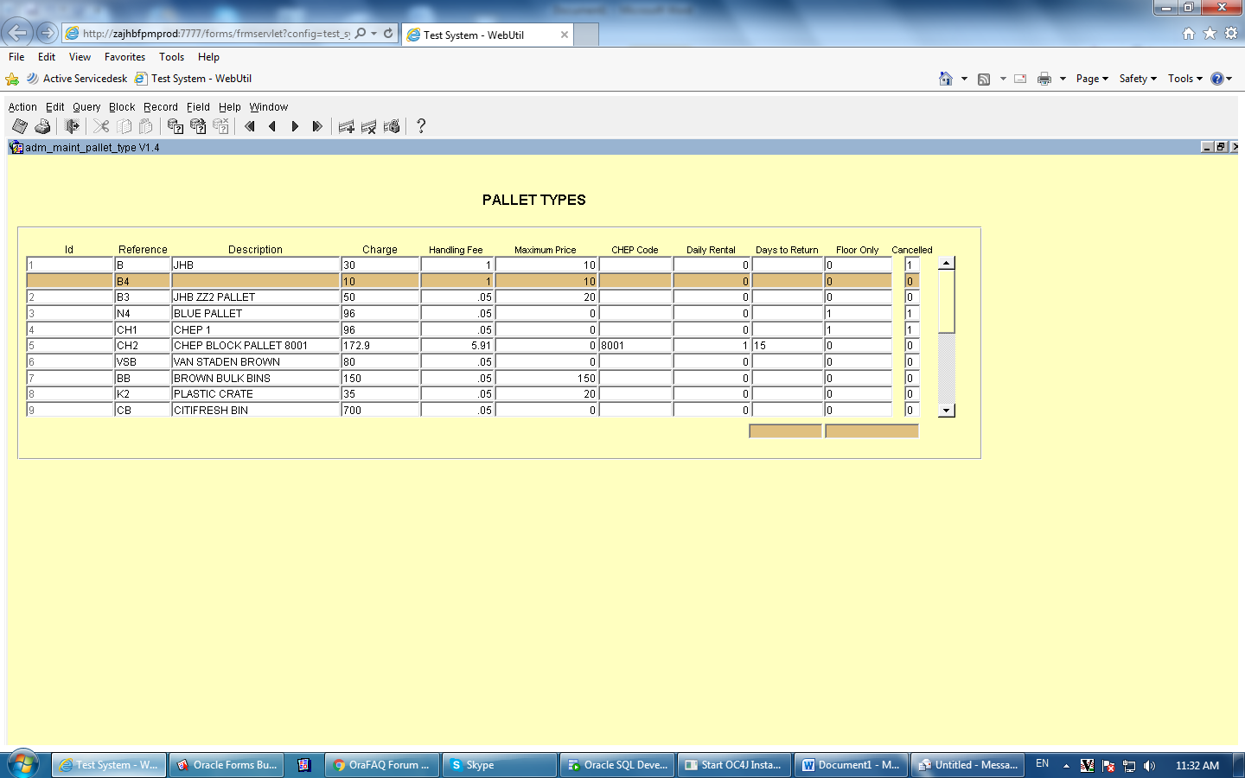
The Pre insert have the following code:
--PRE_INSERT CODE
:SPT_PALLET_TYPES.CANCELLED := 0 ;
SPT_PALLET_TYPES.ID := SPF_PALLET_TYPES_SEQ; --the function code returns the sequence form DB.

/*
create or replace FUNCTION "SPF_PALLET_TYPES_SEQ" RETURN NUMBER
IS
NEW_SEQ NUMBER(17,0);
BEGIN
SELECT SPS_PALLET_TYPES_SEQ.NEXTVAL
INTO NEW_SEQ FROM DUAL;
RETURN NEW_SEQ;
END;*/

if not( :SPT_PALLET_TYPES.DESCRIPTION IS NOT NULL ) then
jfpm_message(1000,null,'Description Requiered');
raise form_trigger_failure;
end if;

if not( :SPT_PALLET_TYPES.CHARGE IS NOT NULL ) then
jfpm_message(1000,null,'Charges Requiered');
raise form_trigger_failure;
end if;

if not( :SPT_PALLET_TYPES.CANCELLED IN (1, 0) ) then
jfpm_message(1000,null,'Cancelled can only be 1 or 0');
raise form_trigger_failure;
end if;

In the pre-insert there is a validation that checks if description field have value or not, if I insert new record with no description value validation is not popping up.

When I’m inserting or deleting the record it not inserted/deleted in the table. No error message displayed

The update is working fine.

I did put the message in the pre-insert it’s not displayed.
jfpm_message(1001,null,'Maximum value in SEQ'||SPF_PALLET_TYPES_SEQ);

