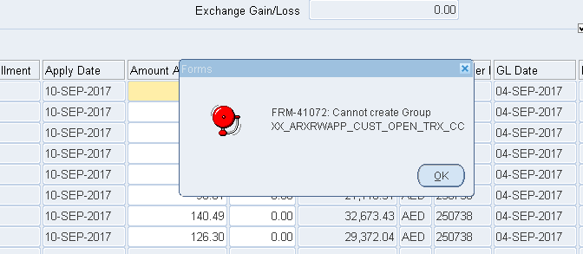

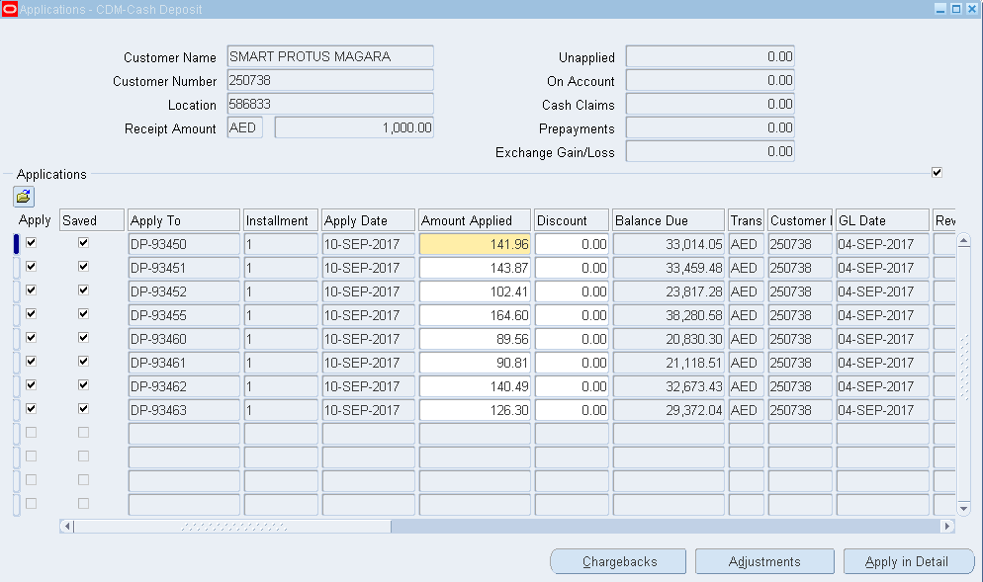

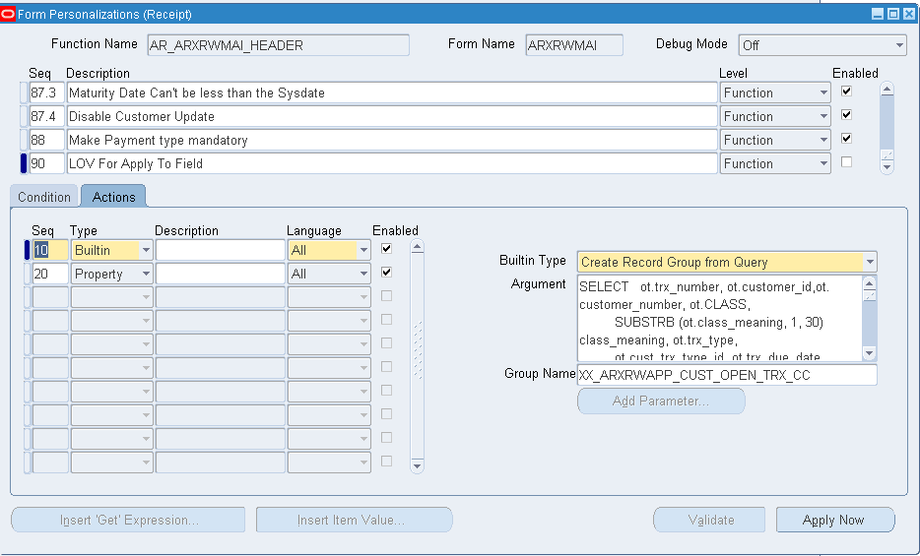

SELECT ot.trx_number, ot.customer_id,ot.customer_number, ot.CLASS,
SUBSTRB (ot.class_meaning, 1, 30) class_meaning, ot.trx_type,
ot.cust_trx_type_id, ot.trx_due_date ,
SUBSTRB(DECODE (SIGN (ot.payment_schedule_id),-1, :app_main.currency_code,ot.invoice_currency_code), 1,15) invoice_currency_code,
ot.balance_due_curr,
DECODE (SIGN (ot.payment_schedule_id),
-1, TO_NUMBER (NULL),
ot.balance_due_functional
) balance_due_functional,
ot.customer_name, ot.LOCATION,
DECODE (SIGN (ot.payment_schedule_id),
-1, TO_NUMBER (NULL),
ot.trx_exchange_rate
) trx_exchange_rate,
ot.trx_date trx_date,
DECODE (SIGN (ot.payment_schedule_id),
-1, TO_DATE (NULL),
ot.trx_gl_date
) trx_gl_date,
ot.calc_discount_on_lines_flag, ot.partial_discount_flag,
ot.allow_overapplication_flag, ot.natural_application_only_flag,
ot.creation_sign, ot.payment_schedule_id, ot.terms_sequence_number,
ot.customer_trx_id,
GREATEST
(TO_DATE (:app_main.cr_gl_date),
ot.trx_gl_date,
DECODE (fnd_profile.VALUE ('AR_APPLICATION_GL_DATE_DEFAULT'),
'INV_REC_SYS_DT', SYSDATE,
'INV_REC_DT', ot.trx_gl_date,
ot.trx_gl_date
)
) gl_date,
DECODE (ot.default_reference,
'1', ot.interface_header_attribute1,
'2', ot.interface_header_attribute2,
'3', ot.interface_header_attribute3,
'4', ot.interface_header_attribute4,
'5', ot.interface_header_attribute5,
'6', ot.interface_header_attribute6,
'7', ot.interface_header_attribute7,
'8', ot.interface_header_attribute8,
'9', ot.interface_header_attribute9,
'10', ot.interface_header_attribute10,
'11', ot.interface_header_attribute11,
'12', ot.interface_header_attribute12,
'13', ot.interface_header_attribute13,
'14', ot.interface_header_attribute14,
'15', ot.interface_header_attribute15,
NULL
) REFERENCE,
ot.term_id,
DECODE (SIGN (ot.payment_schedule_id),
-1, TO_NUMBER (NULL),
ot.amount_due_original
) amount_due_original,
ot.amount_line_items_original, ot.balance_due_curr_unformatted,
ot.discount_taken_earned, ot.discount_taken_unearned,
ot.trx_batch_source_name ,
ot.amount_adjusted ,
ot.amount_adjusted_pending ,
ot.amount_line_items_remaining ,
ot.freight_original ,
ot.freight_remaining ,
ot.receivables_charges_remaining ,
ot.tax_original , ot.tax_remaining ,
ot.selected_for_receipt_batch_id ,
ot.trx_billing_number ,
ot.purchase_order,
ot.bill_to_site_use_id,
SUBSTRB (ot.open_receipt_status_meaning,1,30) open_receipt_status_meaning,
ot.customer_reference,
ot.receivable_application_id, ot.account_description,
ot.customer_reason
FROM ar_open_trx_v ot
WHERE ot.status =
DECODE (:rwapp_control.show_closed_invoices,
'TRUE', ot.status,
'OP'
)
AND NVL (ot.terms_sequence_number, 99) =
NVL (:app_folder.installment, NVL (ot.terms_sequence_number, 99))
ORDER BY nvl(ot.trx_due_date,'01-JAN-1900'),DECODE (SIGN (ot.payment_schedule_id), -1, 0, 4),
ot.trx_number,
ot.customer_name,
ot.terms_sequence_number,
ot.payment_schedule_id

