About Cognizant
Cognizant (NASDAQ: CTSH) is a leading provider of information technology, consulting and business
Process outsourcing services. Cognizant’s single-minded passion is to dedicate our global technology and
Innovation know-how, our industry expertise and worldwide resources to working together with clients to make their business stronger. With more than 40 global delivery centers and approximately 61,700 employees as of December 31, 2008, we combine onsite/offshore model infused by a distinct culture of customer satisfaction. A member of the NASDAQ-100 Index and S&P 500 Index, Cognizant is a Forbes Global 2000 company and a member of the Fortune 1000 and is ranked among the top information technology companies in Business Week’s Hot Growth and Top 50 Performers listings
Start Today
For more information on how to drive your business results with Cognizant, contact us at
inquiry@cognizant.com or visit our website at: www.cognizant.com.


World Headquarters | European Headquarters | India Operations Headquarters
500 Frank W. Burr Blvd. | Haymarket House | #5/535, Old Mahabalipuram Road
Teaneck, NJ 07666 USA | 28-29 Haymarket | Okkiyam Pettai, Thoraipakkam
Phone: +1 201 801 0233 | London SW1Y 4SP UK | Chennai, 600 096 India
Fax: +1 201 801 0243 | Phone: +44 (0) 20 7321 4888 | Phone: +91 (0) 44 4209 6000
Toll Free: +1 888 937 3277 | Fax: +44 (0) 20 7321 4890 | Fax: +91 (0) 44 4209 6060
Email: inquiry@cognizant.com | Email: infouk@cognizant.com | Email: inquiryindia@cognizant.com
© Copyright 2009, Cognizant. All rights reserved. No part of this document may be reproduced, stored in a retrieval system, transmitted in any form or by any means, electronic, mechanical, photocopying, recording, or
otherwise, without the express written permission from Cognizant. The information contained herein is subject to change without notice. All other trademarks mentioned herein are the property of their respective owners.
Contents
Introduction 3
Dimension Schema Used 4
Pre Tuning Scenario 5
Star Transformations 7
Basic Requirements for Star Transformation 15
Summary 17
Attachments 17
References 17

White Paper

Star Transformation in Siebel Analytics(OBIEE)

(Subrata Dass)

Introduction

Star Transformation is a join method mostly used in Data Warehousing Environments to fine tune typical query performance. It is of utmost importance in DB environments where reporting tools like Siebel Analytics (OBIEE) is in use. It can also be used for other tools such as Business Objects. The conventional join mechanisms that the star transformation seeks to supersede are Hash join, nested-loops and sort merge join.

This paper shows how to take full advantage of this RDBMS feature. Another myth it dispels is the fact that implementation of the Star Query is not possible without creating a physical primary key foreign key dependency between the fact and the dimension tables

All the necessary database parameters and other settings required for the set up of this feature have been highlighted in this paper. Parts of this paper which include the understanding of Star Transformation concept have been influenced by the paper →Supercharging Star Transformations by Jeff Maresh in particular and various other Oracle resources mentioned in the References section

All the results in this paper were produced on Oracle 10.2.0.4 64 Bit

.

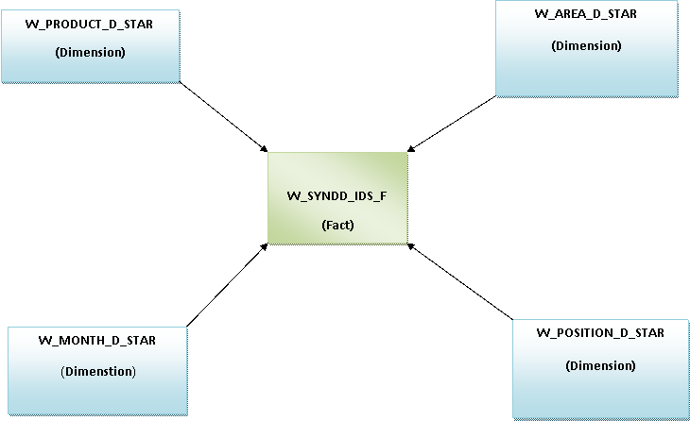

Dimension Schema Used

The Schema used in this paper is same as the one shown above. It is a real life schema currently in use in a renowned pharmaceutical company. The following tables have been used to create the scenario described in this paper

- W_SYNDD_IDS_F_BKP is the fact table that has been used. It mainly contains 3rd party sales data of the various products which are sold by the company. The fact table has 10 years sales data from 2001 – 2010 stored at a monthly granularity level. The table is un-partitioned and has about 3.6 million rows
- W_PRODUCT_D_STAR is a dimension table used in this scenario. It mainly contains data regarding the various products which are in use by the company. It has been created from the W_PRODUCT_D table using the following statement

create table w_product_d_star as select * from W_PRODUCT_D

- W_MONTH_D_STAR is the time dimension table. It has time data on a monthly granule for 10 years

- W_AREA_D_STAR is the dimension table containing the information regarding the various areas in which the company is operating. Since the table has data at a province level granularity for the different states the number of records in this table is huge. Total count of records for this table is 3.6 million.

All the dimension tables have a numeric (Logical) primary key comprised of a sequence-generated number, also known as a surrogate key. The fact table columns include the surrogate key for each of the dimension tables, and a column to hold the measure value. Since one of the main objectives of this paper is to dispel the myth of the presence of primary key and foreign keys as a necessary precondition for Star Transformation such constraints have deliberately not been created.

The schema in use here is a bit small by Data warehousing standards where the size of the tablespaces tends to be to the tune of terabytes. However because of the nature of this analysis the goal is to have a median query timing of about 3 seconds, which is considerably lower than the industry average of 30 seconds to 3 minutes for most warehousing environments

Pre Tuning Scenario

Prior to illustrating the benefits of star transformations, it is useful to get a clear picture as to how the Oracle CBO tends to behave in the absence of this feature. In doing so, the reader will gain a greater appreciation of the capabilities of star transformation. Consider the following query run against the above schema.

/* Formatted on 2010/08/16 14:12 (Formatter Plus v4.8.6) */
SELECT SUM (f.s_amt), d1.prod_name, d5.x_ath_position_name
FROM w_syndd_ids_f_bkp f,
w_product_d_star d1,
w_month_d_star d2,
w_area_d_star d3,
w_position_d_star d5
WHERE f.prod_wid = d1.row_wid
AND d1.prod_name = 'Rebif'
AND f.month_wid = d2.row_wid
AND f.x_ath_country_id = d3.x_ath_country_id
AND d3.x_ath_country_id = 'IT'
AND d5.x_ath_pos_level_tx = 4
AND d5.x_ath_position_name = '4GRN0000_TADir'
AND d2.cal_month = 9
AND d2.cal_year = 2009
AND d5.row_wid = f.x_ath_postn_wid
GROUP BY d1.prod_name, d5.x_ath_position_name

The Query will produce a sales report for the total sales of the product named ‘Rebif’ in the country of Italy in September 2009 under the person having the position name '4GRN0000_TADir' and having a position level of 4

Assuming that hash joins have been enabled on the instance, the query will execute according to the following execution plan.
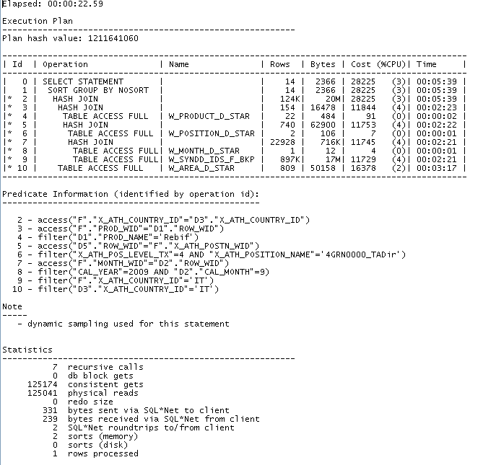
The query follows the following steps . In the first step(Steps 7,8,9) the W_MONTH_D_STAR table is scanned and a hash table is created in the memory of the same . This table is created due to the presence of a limiting condition on the month of September 2009 which fetches a single row. This is then joined to the fact table. This rowset is then joined to the W_POSITION_D (Step 5,6)which has a limiting condition on the x_ath_position_name column .

Further the row set thus obtained is joined to the product dimension(Step 3,5) and finally to the area dimension (Step 2,10). In the final step (Step 1) the group by is done as specified in the query

This query does 125041 physical reads and 125174 consistent gets and returns a single row in 23 seconds after grouping by 3960 records. While this is not a bad timings considering the usual 30 seconds SLA for Warehousing environments , we have to keep in mind that the objective of this paper is to reach a median timing of about 3 seconds . Much improvement is required to achive this higher requirement

We can have a better understanding of why the query is running ineffiecienly by analysing the join methods it is inherently using. Point to be noted here is that no single limiting condition applied to the fact table produces a small row set. The first join between the Month dimension and the fact table results in a row set containing 1.5 million rows, or 42% of the entire table. Each successive join to a dimension table culls more rows, until the result of 3,960 rows is finally reached. While other indexing strategies, join orders, and join types may be employed in an attempt to improve performance, the fundamental problem is that the query will always be driven by joining a single dimension table to the fact table. This always results in a very large row set that will only be reduced by successive joins.

Star Transformations
The mechanism described below has been quoted from Supercharging Star Transformation by Jeff Maresh .
“The star transformation is a join methodology that overcomes this problem by efficiently joining all dimension tables before accessing the fact table. The following steps show how a basic star transformation is performed within the Oracle RDBMS.
- Build lists of fact table ROWIDs for each dimension table.
  - Build a list of dimension table ROWIDs for a dimension based upon the limiting conditions in the query. This is achieved using one of two methods. For small dimensions, the table is scanned. For large dimensions, one or more bitmap indexes are accessed, Boolean operations are performed to arrive at a final unique set of ROWIDs, and the dimension table is accessed accordingly. In the above schema design, the dimension key is the sequence generated primary key.
  - Using the dimension keys from step 1a, access the corresponding bitmap index on the fact table. This produces a list of fact table ROWIDs that match a single dimension key. This step is repeated for each value of the dimension key.
  - Merge the results from all dimension keys for a particular dimension to produce a unique list of fact table ROWIDs and Boolean indicators. The indicators in the list would logically appear as any of the four columns, D1 through D4, which represent each value of all limiting conditions specified in the query. (Figure 2)
  - Repeat steps 1a through 1c for all dimension tables in the query.

- Perform an AND operation across each row of the lists, again illustrated in Figure 2. Only rows with values of 1 (TRUE) in each of the four dimensions will result in a value of 1 in the result column. Any result column with a value of 0 means that the fact table ROWID in question fails to meet all of the limiting conditions, so it should not be included in the result set. Conversely, a value of 1 indicates that the ROWID meets all of the limiting conditions.
- Using the fact table ROWIDs from step 2, retrieve the fact table rows.
- Join back to each dimension using the dimension key from the fact table rows to retrieve any attribute columns requested in the query. The most efficient access and join method will be used for this operation.
- Perform any aggregation operations on the result set.”

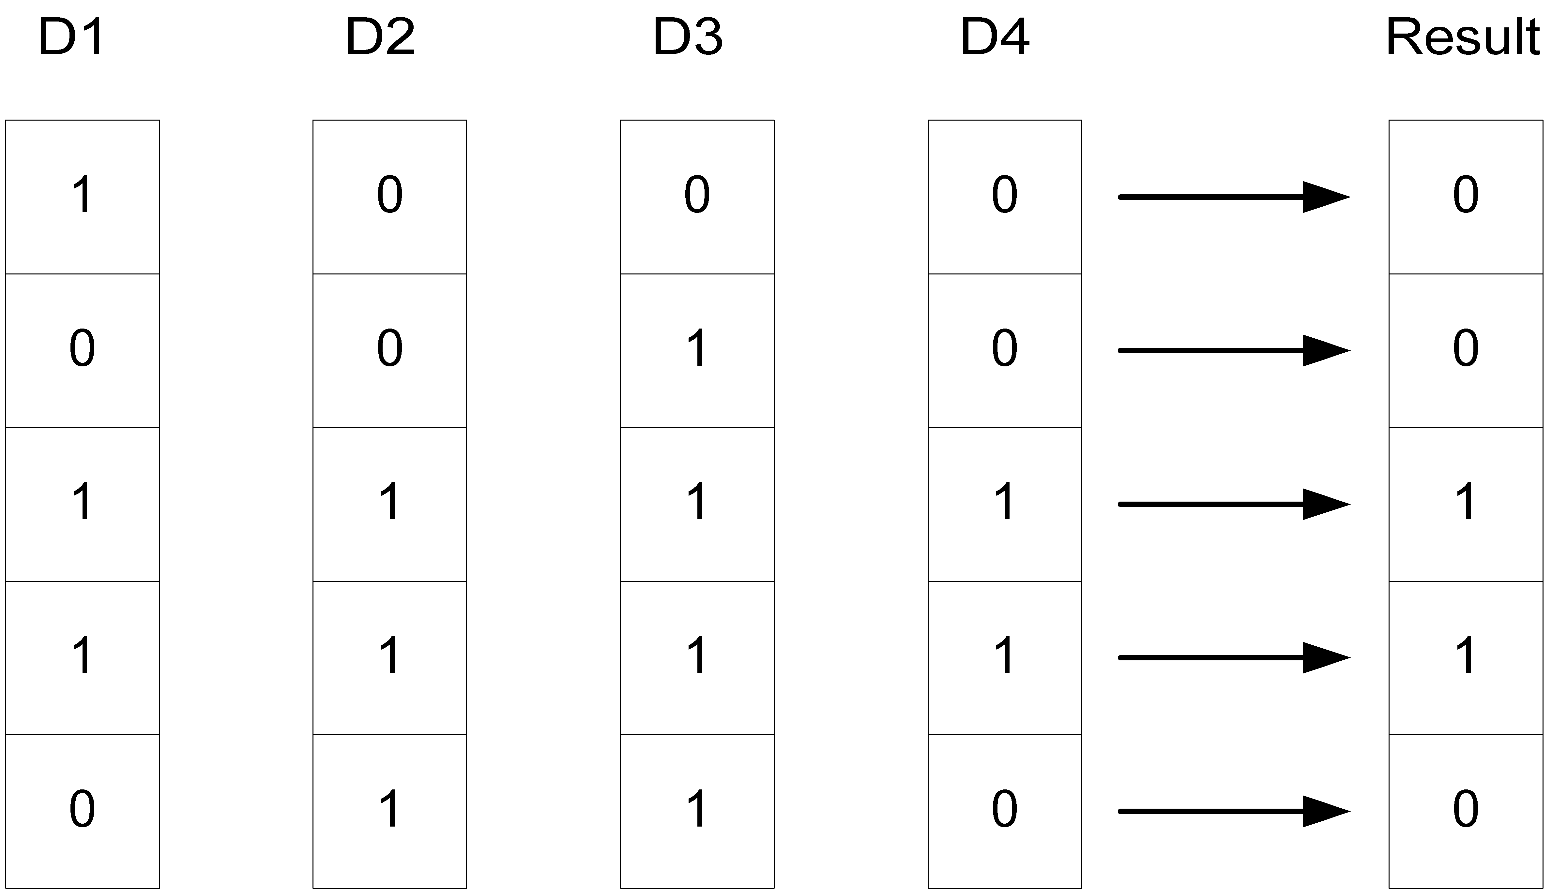

Figure 2- Star Transformation Boolean Operations

To make the query take up this execution path the following bitmap indexes are created in the fact and dimension tables
--------------------------------------------------------------------------------------------------------------------------
create bitmap index pk_f_idx on w_syndd_ids_f_bkp(row_wid);

create bitmap index prod_wid_idx_f on w_syndd_ids_f_bkp(prod_wid);

create bitmap index month_wid_idx_f on w_syndd_ids_f_bkp(month_wid);

create bitmap index x_ath_country_id_idx_f on w_syndd_ids_f_bkp(x_ath_country_id);

create bitmap index x_ath_postn_wid_idx_f on w_syndd_ids_f_bkp(x_ath_postn_wid);

create bitmap index row_wid_d1_idx on w_product_d_star(row_wid);

create bitmap index row_wid_d2_idx on w_month_d_star(row_wid);

create bitmap index row_wid_d3_idx on w_area_d_star(row_wid);

create bitmap index row_wid_d5_idx on w_position_d_star(row_wid);
--------------------------------------------------------------------
Basically a bitmap index is created on each of the joining keys used in the query , one each in the fact and the dimension table . An extra index is created on the column which is the logical primary key of the fact table . In total for a join of 4 dimension with a single fact based on 4 keys a total of 9 indexes (4 on the dimensions and 5 on the fact) are created .

The following are the explain plans obtained based on two value of the star_transformation_enabled → true , temp_disabled

Star_Transformation = True
SQL> SELECT SUM (f.s_amt), d1.prod_name, d5.x_ath_position_name
2 FROM w_syndd_ids_f_bkp f,
3 w_product_d_star d1,
4 w_month_d_star d2,
5 w_area_d_star d3,
6 w_position_d_star d5
7 WHERE f.prod_wid = d1.row_wid
8 AND d1.prod_name = 'Rebif'
9 AND f.month_wid = d2.row_wid
10 AND f.x_ath_country_id = d3.x_ath_country_id
11 AND d3.x_ath_country_id = 'IT'
12 AND x_ath_pos_level_tx = 4
13 AND x_ath_position_name = '4GRN0000_TADir'
14 AND d2.cal_month = 9
15 AND cal_year = 2009
16 AND d5.row_wid = f.x_ath_postn_wid
17 GROUP BY d1.prod_name, d5.x_ath_position_name;

Elapsed: 00:00:15.03

Execution Plan
----------------------------------------------------------
Plan hash value: 449600493

------------------------------------------------------------------------------------------------------------------
| Id | Operation | Name | Rows | Bytes | Cost (%CPU)| Time |
------------------------------------------------------------------------------------------------------------------
| 0 | SELECT STATEMENT | | 1 | 169 | 16589 (2)| 00:03:20 |
| 1 | TEMP TABLE TRANSFORMATION | | | | | |
| 2 | LOAD AS SELECT | SYS_TEMP_0FD9D6DDF_1156B922 | | | | |
|* 3 | TABLE ACCESS FULL | W_PRODUCT_D_STAR | 22 | 484 | 91 (0)| 00:00:02 |
| 4 | HASH GROUP BY | | 1 | 169 | 16498 (2)| 00:03:18 |
|* 5 | HASH JOIN | | 1 | 169 | 16498 (2)| 00:03:18 |

|* 6 | HASH JOIN | | 1 | 107 | 119 (2)| 00:00:02
|
|* 7 | HASH JOIN | | 1 | 85 | 116 (1)| 00:00:02 |
|* 8 | HASH JOIN | | 1 | 32 | 109 (1)| 00:00:02 |
|* 9 | TABLE ACCESS FULL | W_MONTH_D_STAR | 1 | 12 | 4 (0)| 00:00:01 |
| 10 | TABLE ACCESS BY INDEX ROWID | W_SYNDD_IDS_F_BKP | 4 | 80 | 104 (0)| 00:00:02 |
| 11 | BITMAP CONVERSION TO ROWIDS| | | | | |
| 12 | BITMAP AND | | | | | |
| 13 | BITMAP MERGE | | | | | |
| 14 | BITMAP KEY ITERATION | | | | | |
| 15 | TABLE ACCESS FULL | SYS_TEMP_0FD9D6DDF_1156B922 | 1 | 13 | 2 (0)| 00:00:01 |
|* 16 | BITMAP INDEX RANGE SCAN| PROD_WID_IDX_F | | | | |
| 17 | BITMAP MERGE | | | | | |
| 18 | BITMAP KEY ITERATION | | | | | |
|* 19 | TABLE ACCESS FULL | W_MONTH_D_STAR | 1 | 12 | 4 (0)| 00:00:01 |
|* 20 | BITMAP INDEX RANGE SCAN| MONTH_WID_IDX_F | | | | |
| 21 | BITMAP MERGE | | | | | |
| 22 | BITMAP KEY ITERATION | | | | | |
|* 23 | TABLE ACCESS FULL | W_POSITION_D_STAR | 2 | 106 | 7 (0)| 00:00:01 |
|* 24 | BITMAP INDEX RANGE SCAN| X_ATH_POSTN_WID_IDX_F | | | | |
|* 25 | BITMAP INDEX SINGLE VALUE| X_ATH_COUNTRY_ID_IDX_F | | | | |
|* 26 | TABLE ACCESS FULL | W_POSITION_D_STAR | 2 | 106 | 7 (0)| 00:00:01 |
| 27 | TABLE ACCESS FULL | SYS_TEMP_0FD9D6DDF_1156B922 | 22 | 484 | 2 (0)| 00:00:01 |
|* 28 | TABLE ACCESS FULL | W_AREA_D_STAR | 809 | 50158 | 16378 (2)| 00:03:17 |
------------------------------------------------------------------------------------------------------------------

Predicate Information (identified by operation id):
---------------------------------------------------

3 - filter("D1"."PROD_NAME"='Rebif')
5 - access("F"."X_ATH_COUNTRY_ID"="D3"."X_ATH_COUNTRY_ID")
6 - access("F"."PROD_WID"="C0")
7 - access("D5"."ROW_WID"="F"."X_ATH_POSTN_WID")
8 - access("F"."MONTH_WID"="D2"."ROW_WID")
9 - filter("CAL_YEAR"=2009 AND "D2"."CAL_MONTH"=9)
16 - access("F"."PROD_WID"="C0")
19 - filter("CAL_YEAR"=2009 AND "D2"."CAL_MONTH"=9)
20 - access("F"."MONTH_WID"="D2"."ROW_WID")
23 - filter("X_ATH_POS_LEVEL_TX"=4 AND "X_ATH_POSITION_NAME"='4GRN0000_TADir')
24 - access("F"."X_ATH_POSTN_WID"="D5"."ROW_WID")
25 - access("F"."X_ATH_COUNTRY_ID"='IT')
26 - filter("X_ATH_POS_LEVEL_TX"=4 AND "X_ATH_POSITION_NAME"='4GRN0000_TADir')
28 - filter("D3"."X_ATH_COUNTRY_ID"='IT')

Note
-----
- dynamic sampling used for this statement
- star transformation used for this statement

Statistics
----------------------------------------------------------
120 recursive calls
11 db block gets
73988 consistent gets
39794 physical reads
1584 redo size
314 bytes sent via SQL*Net to client
239 bytes received via SQL*Net from client
2 SQL*Net roundtrips to/from client
4 sorts (memory)
0 sorts (disk)
- rows processed

Star Transformation = Temp_disabled

SQL> alter session set star_transformation_enabled=temp_disable;

Session altered.

Elapsed: 00:00:00.01
SQL> alter session set events 'immediate trace name flush_cache';

Session altered.

Elapsed: 00:00:00.92
SQL> SELECT SUM (f.s_amt), d1.prod_name, d5.x_ath_position_name
2 FROM w_syndd_ids_f_bkp f,
3 w_product_d_star d1,
4 w_month_d_star d2,
5 w_area_d_star d3,
6 w_position_d_star d5
7 WHERE f.prod_wid = d1.row_wid
8 AND d1.prod_name = 'Rebif'
9 AND f.month_wid = d2.row_wid
10 AND f.x_ath_country_id = d3.x_ath_country_id
11 AND d3.x_ath_country_id = 'IT'
12 AND x_ath_pos_level_tx = 4
13 AND x_ath_position_name = '4GRN0000_TADir'
14 AND d2.cal_month = 9
15 AND cal_year = 2009
16 AND d5.row_wid = f.x_ath_postn_wid
17 GROUP BY d1.prod_name, d5.x_ath_position_name;

Elapsed: 00:00:16.29

Execution Plan
----------------------------------------------------------
Plan hash value: 3326886004

------------------------------------------------------------------------------------------------------------
| Id | Operation | Name | Rows | Bytes | Cost (%CPU)| Time |
------------------------------------------------------------------------------------------------------------
| 0 | SELECT STATEMENT | | 1 | 169 | 16587 (2)| 00:03:20 |
| 1 | SORT GROUP BY NOSORT | | 1 | 169 | 16587 (2)| 00:03:20 |
|* 2 | HASH JOIN | | 1 | 169 | 16587 (2)| 00:03:20 |
|* 3 | HASH JOIN | | 1 | 107 | 208 (1)| 00:00:03 |
|* 4 | HASH JOIN | | 1 | 85 | 116 (1)| 00:00:02 |
|* 5 | HASH JOIN | | 1 | 32 | 109 (1)| 00:00:02 |
|* 6 | TABLE ACCESS FULL | W_MONTH_D_STAR | 1 | 12 | 4 (0)| 00:00:01 |
| 7 | TABLE ACCESS BY INDEX ROWID | W_SYNDD_IDS_F_BKP | 4 | 80 | 104 (0)| 00:00:02 |
| 8 | BITMAP CONVERSION TO ROWIDS| | | | | |
| 9 | BITMAP AND | | | | | |
| 10 | BITMAP MERGE | | | | | |
| 11 | BITMAP KEY ITERATION | | | | | |
|* 12 | TABLE ACCESS FULL | W_PRODUCT_D_STAR | 22 | 484 | 91 (0)| 00:00:02 |
|* 13 | BITMAP INDEX RANGE SCAN| PROD_WID_IDX_F | | | | |
| 14 | BITMAP MERGE | | | | | |
| 15 | BITMAP KEY ITERATION | | | | | |
|* 16 | TABLE ACCESS FULL | W_MONTH_D_STAR | 1 | 12 | 4 (0)| 00:00:01 |
|* 17 | BITMAP INDEX RANGE SCAN| MONTH_WID_IDX_F | | | | |
| 18 | BITMAP MERGE | | | | | |
| 19 | BITMAP KEY ITERATION | | | | | |
|* 20 | TABLE ACCESS FULL | W_POSITION_D_STAR | 2 | 106 | 7 (0)| 00:00:01 |
|* 21 | BITMAP INDEX RANGE SCAN| X_ATH_POSTN_WID_IDX_F | | | | |
|* 22 | BITMAP INDEX SINGLE VALUE| X_ATH_COUNTRY_ID_IDX_F | | | | |
|* 23 | TABLE ACCESS FULL | W_POSITION_D_STAR | 2 | 106 | 7 (0)| 00:00:01 |
|* 24 | TABLE ACCESS FULL | W_PRODUCT_D_STAR | 22 | 484 | 91 (0)| 00:00:02 |
|* 25 | TABLE ACCESS FULL | W_AREA_D_STAR | 809 | 50158 | 16378 (2)| 00:03:17 |
------------------------------------------------------------------------------------------------------------

Predicate Information (identified by operation id):
---------------------------------------------------

2 - access("F"."X_ATH_COUNTRY_ID"="D3"."X_ATH_COUNTRY_ID")
3 - access("F"."PROD_WID"="D1"."ROW_WID")
4 - access("D5"."ROW_WID"="F"."X_ATH_POSTN_WID")
5 - access("F"."MONTH_WID"="D2"."ROW_WID")
6 - filter("CAL_YEAR"=2009 AND "D2"."CAL_MONTH"=9)
12 - filter("D1"."PROD_NAME"='Rebif')
13 - access("F"."PROD_WID"="D1"."ROW_WID")
16 - filter("CAL_YEAR"=2009 AND "D2"."CAL_MONTH"=9)
17 - access("F"."MONTH_WID"="D2"."ROW_WID")
20 - filter("X_ATH_POS_LEVEL_TX"=4 AND "X_ATH_POSITION_NAME"='4GRN0000_TADir')
21 - access("F"."X_ATH_POSTN_WID"="D5"."ROW_WID")
22 - access("F"."X_ATH_COUNTRY_ID"='IT')
23 - filter("X_ATH_POS_LEVEL_TX"=4 AND "X_ATH_POSITION_NAME"='4GRN0000_TADir')
24 - filter("D1"."PROD_NAME"='Rebif')
25 - filter("D3"."X_ATH_COUNTRY_ID"='IT')

Note
-----
- dynamic sampling used for this statement
- star transformation used for this statement

Statistics
----------------------------------------------------------
13 recursive calls
0 db block gets
74264 consistent gets
73666 physical reads
0 redo size
331 bytes sent via SQL*Net to client
239 bytes received via SQL*Net from client
2 SQL*Net roundtrips to/from client
2 sorts (memory)
0 sorts (disk)
1 rows processed

--------------------------------------------------------------------------------------------------------------------
The two values are tried out because in a lot of cases in Oracle 10G there are bugs related to the temp table creation which takes place when the value of the parameter star_transformation_enabled is set to true.

When the query above executes a star transformation, the following execution plan is taken as a result. Each of the three blocks beginning with step 11 in the second case and step 14 in the first case in the execution plan corresponds to step 1 in the star transformation. Steps 8 and 9 in the first and steps 11 and 12 in the second execution plan correspond to step 2 in the above description, while the second occurrence of step 7 in the second and step 10 in the first execution plan corresponds to step 3 in the description. Step 1 in the execution plan corresponds to step 4 in the above description.

In the above two examples there is an improvement in timing from 23 seconds to about 15 seconds . However even though this timing is good it is still not near enough our goal of 3 seconds

This brings us to our second phase where we create single bitmap indexes on each of the columns in the dimension tables on which a filter condition is applied . The following indexes are created
--------------------------------------------------------------------------------------------------------------------------
create bitmap index prod_name_d1_idx on w_product_d_star(prod_name);

create bitmap index x_ath_country_id_d3_idx on w_area_d_star(x_ath_country_id);

create bitmap index x_ath_pos_level_tx_d5_idx on w_position_d_star(x_ath_pos_level_tx);

create bitmap index x_ath_position_name_d5_idx on w_position_d_star(x_ath_position_name);

create bitmap index cal_year_d2_idx on w_month_d_star(cal_year) ;

create bitmap index cal_month_d2_idx on w_month_d_star(cal_month);
-----------------------------------------------------------------------------------------------------------------

Now when the query is executed again it executes using the following explain plan

SQL> SELECT SUM (f.s_amt), d1.prod_name, d5.x_ath_position_name
2 FROM w_syndd_ids_f_bkp f,
3 w_product_d_star d1,
4 w_month_d_star d2,
5 w_area_d_star d3,
6 w_position_d_star d5
7 WHERE f.prod_wid = d1.row_wid
8 AND d1.prod_name = 'Rebif'
9 AND f.month_wid = d2.row_wid
10 AND f.x_ath_country_id = d3.x_ath_country_id
11 AND d3.x_ath_country_id = 'IT'
12 AND d5.x_ath_pos_level_tx = 4
13 AND d5.x_ath_position_name = '4GRN0000_TADir'
14 AND d2.cal_month = 9
15 AND d2.cal_year = 2009
16 AND d5.row_wid = f.x_ath_postn_wid
17 GROUP BY d1.prod_name, d5.x_ath_position_name;

Elapsed: 00:00:01.07

Execution Plan
----------------------------------------------------------
Plan hash value: 2106571917

----------------------------------------------------------------------------------------------------------------------
| Id | Operation | Name | Rows | Bytes | Cost (%CPU)| Time |
----------------------------------------------------------------------------------------------------------------------
| 0 | SELECT STATEMENT | | 1 | 169 | 32 (10)| 00:00:01 |
| 1 | SORT GROUP BY NOSORT | | 1 | 169 | 32 (10)| 00:00:01 |
|* 2 | HASH JOIN | | 1 | 169 | 32 (10)| 00:00:01 |
|* 3 | HASH JOIN | | 1 | 107 | 31 (10)| 00:00:01 |
|* 4 | HASH JOIN | | 1 | 85 | 21 (10)| 00:00:01 |
|* 5 | HASH JOIN | | 1 | 32 | 18 (6)| 00:00:01 |
| 6 | TABLE ACCESS BY INDEX ROWID | W_MONTH_D_STAR | 1 | 12 | 2 (0)| 00:00:01 |
| 7 | BITMAP CONVERSION TO ROWIDS | | | | | |
| 8 | BITMAP AND | | | | | |
|* 9 | BITMAP INDEX SINGLE VALUE | CAL_YEAR_D2_IDX | | | | |
|* 10 | BITMAP INDEX SINGLE VALUE | CAL_MONTH_D2_IDX | | | | |
| 11 | TABLE ACCESS BY INDEX ROWID | W_SYNDD_IDS_F_BKP | 4 | 80 | 16 (7)| 00:00:01 |
| 12 | BITMAP CONVERSION TO ROWIDS | | | | | |
| 13 | BITMAP AND | | | | | |
| 14 | BITMAP MERGE | | | | | |
| 15 | BITMAP KEY ITERATION | | | | | |
|* 16 | VIEW | index$_join$_007 | 22 | 484 | 10 (10)| 00:00:01 |

|* 17 | HASH JOIN | | | | | |
| 18 | BITMAP CONVERSION TO ROWIDS| | 22 | 484 | 1 (0)| 00:00:01 |
|* 19 | BITMAP INDEX SINGLE VALUE | PROD_NAME_D1_IDX | | | | |
| 20 | BITMAP CONVERSION TO ROWIDS| | 22 | 484 | 8 (0)| 00:00:01 |
| 21 | BITMAP INDEX FULL SCAN | ROW_WID_D1_IDX | | | | |
|* 22 | BITMAP INDEX RANGE SCAN | PROD_WID_IDX_F | | | | |
| 23 | BITMAP MERGE | | | | | |
| 24 | BITMAP KEY ITERATION | | | | | |
| 25 | TABLE ACCESS BY INDEX ROWID | W_POSITION_D_STAR | 2 | 106 | 2 (0)| 00:00:01 |
| 26 | BITMAP CONVERSION TO ROWIDS | | | | | |
| 27 | BITMAP AND | | | | | |
|* 28 | BITMAP INDEX SINGLE VALUE | X_ATH_POSITION_NAME_D5_IDX | | | | |
|* 29 | BITMAP INDEX SINGLE VALUE | X_ATH_POS_LEVEL_TX_D5_IDX | | | | |
|* 30 | BITMAP INDEX RANGE SCAN | X_ATH_POSTN_WID_IDX_F | | | | |
| 31 | BITMAP MERGE | | | | | |
| 32 | BITMAP KEY ITERATION | | | | | |
| 33 | TABLE ACCESS BY INDEX ROWID | W_MONTH_D_STAR | 1 | 12 | 2 (0)| 00:00:01 |
| 34 | BITMAP CONVERSION TO ROWIDS | | | | | |
| 35 | BITMAP AND | | | | | |
|* 36 | BITMAP INDEX SINGLE VALUE | CAL_YEAR_D2_IDX | | | | |
|* 37 | BITMAP INDEX SINGLE VALUE | CAL_MONTH_D2_IDX | | | | |
|* 38 | BITMAP INDEX RANGE SCAN | MONTH_WID_IDX_F | | | | |
|* 39 | BITMAP INDEX SINGLE VALUE | X_ATH_COUNTRY_ID_IDX_F | | | | |
| 40 | TABLE ACCESS BY INDEX ROWID | W_POSITION_D_STAR | 2 | 106 | 2 (0)| 00:00:01 |
| 41 | BITMAP CONVERSION TO ROWIDS | | | | | |
| 42 | BITMAP AND | | | | | |
|* 43 | BITMAP INDEX SINGLE VALUE | X_ATH_POSITION_NAME_D5_IDX | | | | |
|* 44 | BITMAP INDEX SINGLE VALUE | X_ATH_POS_LEVEL_TX_D5_IDX | | | | |
|* 45 | VIEW | index$_join$_002 | 22 | 484 | 10 (10)| 00:00:01 |
|* 46 | HASH JOIN | | | | | |
| 47 | BITMAP CONVERSION TO ROWIDS | | 22 | 484 | 1 (0)| 00:00:01 |
|* 48 | BITMAP INDEX SINGLE VALUE | PROD_NAME_D1_IDX | | | | |
| 49 | BITMAP CONVERSION TO ROWIDS | | 22 | 484 | 8 (0)| 00:00:01 |
| 50 | BITMAP INDEX FULL SCAN | ROW_WID_D1_IDX | | | | |
| 51 | BITMAP CONVERSION TO ROWIDS | | 264 | 16368 | 1 (0)| 00:00:01 |
|* 52 | BITMAP INDEX SINGLE VALUE | X_ATH_COUNTRY_ID_D3_IDX | | | | |
----------------------------------------------------------------------------------------------------------------------

Predicate Information (identified by operation id):
---------------------------------------------------

2 - access("F"."X_ATH_COUNTRY_ID"="D3"."X_ATH_COUNTRY_ID")
3 - access("F"."PROD_WID"="D1"."ROW_WID")
4 - access("D5"."ROW_WID"="F"."X_ATH_POSTN_WID")
5 - access("F"."MONTH_WID"="D2"."ROW_WID")
9 - access("D2"."CAL_YEAR"=2009)
10 - access("D2"."CAL_MONTH"=9)
16 - filter("D1"."PROD_NAME"='Rebif')
17 - access(ROWID=ROWID)
19 - access("D1"."PROD_NAME"='Rebif')
22 - access("F"."PROD_WID"="D1"."ROW_WID")
28 - access("D5"."X_ATH_POSITION_NAME"='4GRN0000_TADir')
29 - access("D5"."X_ATH_POS_LEVEL_TX"=4)
30 - access("F"."X_ATH_POSTN_WID"="D5"."ROW_WID")
36 - access("D2"."CAL_YEAR"=2009)
37 - access("D2"."CAL_MONTH"=9)
38 - access("F"."MONTH_WID"="D2"."ROW_WID")
39 - access("F"."X_ATH_COUNTRY_ID"='IT')
43 - access("D5"."X_ATH_POSITION_NAME"='4GRN0000_TADir')
44 - access("D5"."X_ATH_POS_LEVEL_TX"=4)
45 - filter("D1"."PROD_NAME"='Rebif')
46 - access(ROWID=ROWID)
48 - access("D1"."PROD_NAME"='Rebif')
52 - access("D3"."X_ATH_COUNTRY_ID"='IT')

Note
-----
- dynamic sampling used for this statement
- star transformation used for this statement

Statistics
----------------------------------------------------------
17 recursive calls
0 db block gets
276 consistent gets

424 physical reads
0 redo size
331 bytes sent via SQL*Net to client
239 bytes received via SQL*Net from client
2 SQL*Net roundtrips to/from client
2 sorts (memory)
0 sorts (disk)
1 rows processed

With the presence of indexes on the limiting condition the query timing using star transformation shows a significant improvement . The entire query executes in about 1 second which is 20 fold gain. The logical read comes down from 125041 to 424 and the consistent gets from 125174 to only 276. This gain in performance is due mainly to two reasons

- The reads in the table have been reduced because only those rows in the fact table are accessed which are grouped by in the final result The inefficient procedure of culling rows from the fact table through successive dimension table joins has been eliminated. Unlike the conventional method that joins a single dimension to the fact table, the star transformation effectively joins all of the dimensions to arrive at a unique set of ROWIDs before accessing the fact table.
- The second reason for the improvement is the prevalence of Boolean operations used in the star transformation. These operations are much more efficient than the more resource consuming hash joins used to cull rows in the conventional execution plan.

On careful viewing it can be seen that a new feature which comes in this case is that there is an additional Index Join Step which comes in between the different bitmap indexes which was not present in the earlier plans

Basic Requirements for Star Transformation

The following are the basic requirements for a star transformation to be considered by the CBO

- Value of parameter STAR_TRANSFORMATION_ENEBLED=TRUE/TEMP_DISABLED

Setting the value of the parameter to TEMP_DISABLED is used as a way around the various bugs which occur in Oracle due to the creation of temp tables which are created on the fly during the process of transformation. These temp tables are totally transparent to the end user but are however visible in the explain plans as shown in the paper

- Value of parameter QUERY_REWRITE_ENABLED=TRUE
- Value of parameter QUERY_REWRITE_INTERITY=TRUSTED

A bitmap index needs to be present on each of the join keys in both the fact and the dimension and the logical primary key in the fact table .

The creation of a primary key and foreign key relationship between the fact and dimension is not at all a necessity and is totally avoidable

If the creation of a bitmap index is not possible then star transformation is possible even by creation of a normal B-Tree index. In that case there will be a further bitmap transformation from the rowids present in the using the BITMAP CONVERSION FROM ROWIDS event. However this is not discussed in the present paper

Proper stats needs to be collected for all the tables which act as participants in a star query . Post 9i the stats needs to be collected using DBMS_STATS.

Sometimes even when proper stats are present the presence /absence of histograms prevents the CBO from taking up a star transformation path . In such cases the value of the parameter optimizer_dynamic_sampling needs to be set to a value of 2 and above to facilitate the collection of statistics on the fly so that the CBO can take up star transformation

Another general problem that is seen when star transformation is involved is that when a star schema is not implemented properly ( Absence of proper indexes etc) star queries tend to do a lot of Cartesian Merge joins which are similar to the star transformation but tend to take a lot more time. In such cases the parameters “ _optimizer_mjc_enabled” and “_optimizer_cartesian_enabled “ can be set to false . Since these are undocumented parameters, setting these parameters at a DB level can cause a lot of problems . In Siebel Analytics/OBIEE the value of these parameters can be changed using a logon script . However due to a bug in Siebel (Below version 10.1.3.4), the usage of these parameters in a rpd logon script causes Siebel to crash . In such a case a DB level trigger can be used which changes the value of these parameters everytime a SIEBEL user logs in . The script is as below

CREATE OR REPLACE TRIGGER rds_logon_trigger
AFTER LOGON ON DATABASE
BEGIN
IF SYS_CONTEXT ('USERENV', 'CURRENT_SCHEMA') IN ('SIEBEL')
THEN
BEGIN
EXECUTE IMMEDIATE 'alter session set "optimizer_mjc_enabled"=false';
EXECUTE IMMEDIATE 'alter session set "optimizer_cartesian_enabled" = FALSE';
END;
END IF;
EXCEPTION
WHEN OTHERS
THEN
NULL;
END;

Summary
The star transformation is a powerful feature for querying dimensional data warehouses. Unlike conventional join methods that can only join two tables at time, the star transformation effectively joins all of the dimension tables to arrive at a composite set of ROWIDs before accessing the fact table. Oracle has enhanced the basic star transformation to greatly improve its performance.
It is no longer a necessity to have a physical primary key foreign key relationship between the fact and dimensions for proper Star Query formation. Neither is the presence of bitmap indexes an absolute necessity. The Index join feature also adds on a new dimension to the star transformation feature
However several other database parameters still needs to be set and there still exists a whole range of bugs with the value of the parameter star_transformation_enabled=true. Workaround is to set the value to temp_disabled. Proper statistics needs to be collected on the underlying table and the parameter optimizer_dynamic_sampling needs to be set to a proper value to smooth roll any statistical discrepancies. All these features if set properly , the star_transformation provides us a unique and exciting weapon in our arsenal to tune and effectively deal with traditional warehousing queries which usually involves mining through a huge volume of data

Attachments

The following are the attachments which contain the script used to create the tables given in the examples and the spool of the test conditions

References

Supercharging Star Transformations by Jeff Maresh Supercharging Star Transformation

Lewis, Jonathan. 2004. Understanding Bitmap Indexes, www.dbazine.com
Lewis, Jonathan. 2004. Bitmap Indexes 2: Star Transformations, www.dbazine.com
Oracle 9i Data Warehousing Guide Release 2 (9.2). 1996, 2002. Oracle Corporation
Scalzo, Bert. 2003. Oracle DBA Guide to Data Warehousing and Star Schemas. Prentice Hall

