How to capture the dsign of a non-Oracle database using Designer 6
Mark Falvo, Computer Resource Team, Inc
Introduction

Oracle Designer allows you to move Oracle or non-Oracle database objects into the repository enabling you to document part of the application, make changes, or diagram the system. Many existing applications have little or no formal documentation for the early stages of development; Designer allows you to store valuable data about the business. I will be covering the steps required to successfully capture a MS Access database using Designer. I will not be covering the steps required in setting up an Oracle Repository. For this presentation I will be using Oracle Designer 6.0.3.8.0, MS Access 97, and the Oracle Enterprise Edition Release 8.1.6.0.0 database, on Windows NT 4 service pack 5.
The Capture Design utility examines existing database objects such as tables, views, and sequences in Oracle or non-Oracle databases and creates Designer/2000 objects. The following table (fig 1) summarizes capturing the design of existing database objects directly from an online database. Supported databases are as follows : Rdb 6.1 and 7.0, DB2/2 and DB2/MVS v 5.1 / 4.1, SQL Server 6.0 and 6.5, Sybase System 11, and ANSI compliant database support.

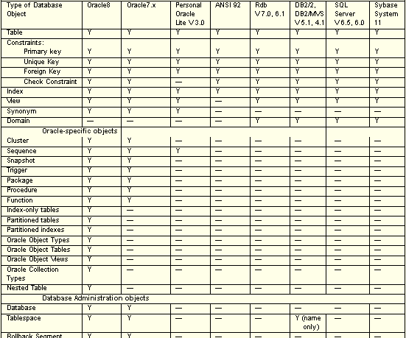
(fig 1) (Oracle Designer Design and Generation)

The following table (fig 2) summarizes capturing the definitions of objects contained in one or more script files into the Repository.

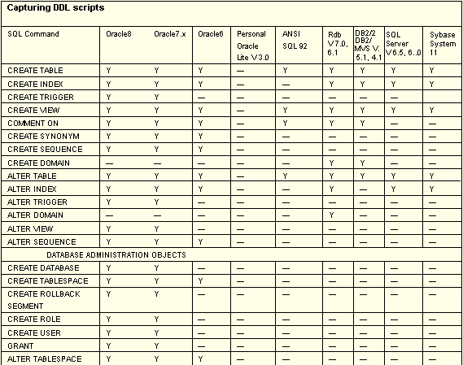
(fig 2) (Oracle Designer Design and Generation)

To begin the process of capturing database objects click on the Design Editor icon from the front panel (fig 3).
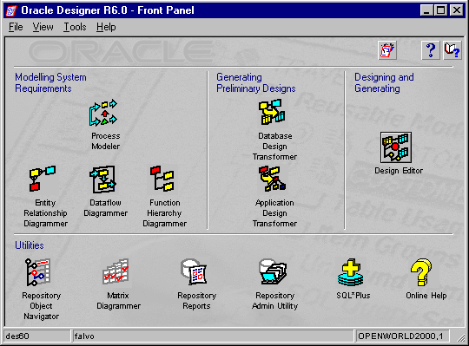
(fig 3)

From the Design Capture utility window (fig 4), which is accessed from the menu ‘Generate/Capture Design of/Server Model’, you can capture the design of existing databases, DDL files, or from an ODBC driver.

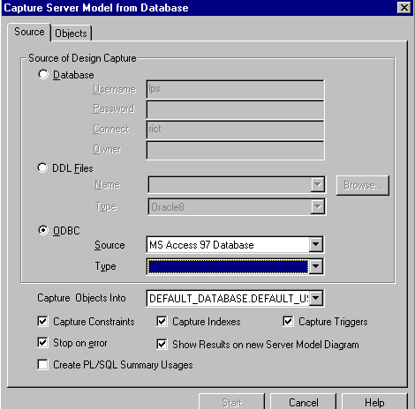
(fig 4)

- The database option (fig 4) allows you to capture definitions from an Oracle database, using a native Oracle SQL*Net connect string.
- The DDL option allows you to capture commands from a DDL script file; the entire contents of the file are captured. The file can contain object definitions or can include calls to other script files that contain DDL commands. The commands must be specified in the file in the correct order.
- The ODBC option (fig 4), which is what will be demonstrated here, allows you to capture database object definitions from any popular SQL database for which you have an installed ODBC driver. The type of the source database, in most circumstances, is determined automatically when the data source is selected. Selection of the blank database type indicates that Server Generator will attempt to read the database type from the ODBC driver. If the database type is recognized then it will be used, otherwise a default type is used.
- Capture objects Into checkbox (fig 4) describes the database and user definition into which the implementation specific properties of the objects will be captured, specified in the format: <database_definition>.<user_definition>.
- Capture Constraints checkbox (fig 4) indicates whether constraints defined against table definitions are to be captured into the Repository: primary key constraints, unique key, constraints, foreign key constraints, and check constraints. To prevent constraints from being captured into the Repository, uncheck this option. Also a constraint cannot be captured without its associated table, and the Constraints defined against views are used specifically for application design, therefore, no DDL commands to create constraints on views can be captured.
- Capture Indexes checkbox (fig 4) indicates whether indexes defined against table/cluster/snapshot definitions are to be captured into the Repository. An index cannot be captured without its associated table, cluster, or snapshot.
- Capture Triggers checkbox (fig 4) captures triggers, a trigger cannot be captured without its associated table.
- Show Results on new Server Model Diagram (fig 4) allows you to display the captured server model (e.g. tables, foreign keys, views, snapshots and clusters).

Once the MS Access 97 Database has been selected in the ODBC section hitting the Objects tab will bring up the popup window (fig 5). I will be using a default database called Northwind.mdb.

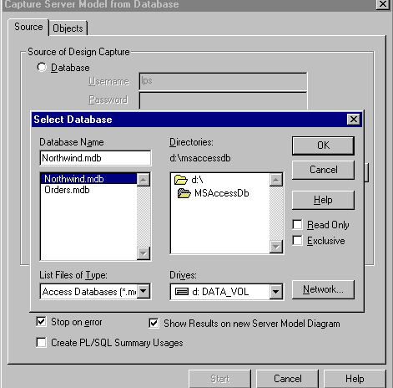
(fig 5)

Available objects allowed to be captured will be displayed in new popup window (fig 6). By clicking the double arrow, all objects will be captured or you can select them individually by using the single arrow. Database administration objects (tablespaces, database files, directories, rollback segments, database users, roles, profiles and replication groups) will only be displayed as selectable objects for capturing if the connected account has database administration privileges.

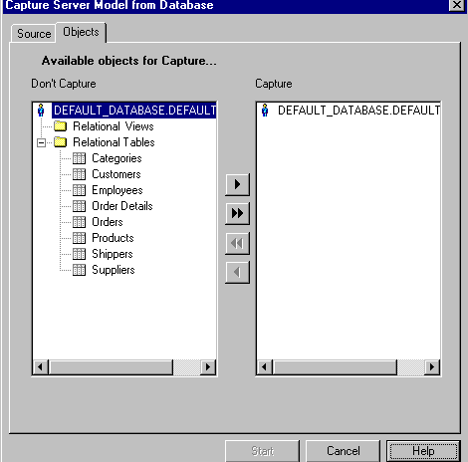
(fig 6)

A message window will popup,and any red messages are errors encountered in the capturing of the database objects. A dialog box will be displayed (fig 7) after generation or design capture. It allows you to specify how proposed changes are to be processed. The proposed changes consist of new definitions that are to be created in the Repository and existing definitions whose properties are to be changed. The names of new or changed Repository definitions are highlighted on the Navigator window.

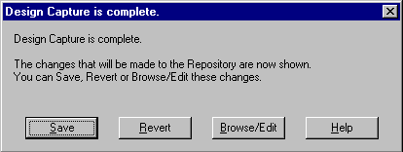
(fig 7)

Save button saves proposed changes to the Repository. Browse/Edit button allows you to view and edit the proposed changes before saving them in the Repository. The proposed changes are highlighted on a diagram (fig 8). For example, if you are capturing tables and roles, the names of the tables and roles are highlighted displayed on the Navigator. The tables are also shown on a Server Model Diagram, but the roles are not. The relationships will be shown in the Entity Relationship Diagrammer.

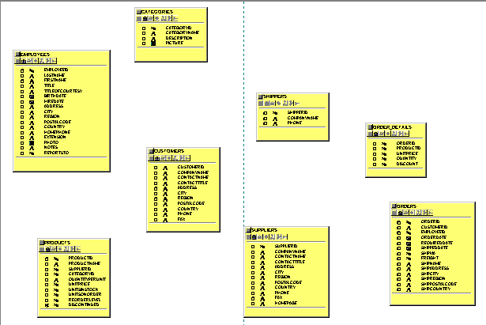
(fig 8)

From the front panel (fig 3), click on the Entity Relationship Diagrammer; from the main menu select ‘Utilities/Table to Entity Retrofit’ and click on ‘Candidate Tables’ (fig 9). From here we will retrofit all the tables listed into entities using the ‘Table to Entity Retrofit’ utility which transforms (or 'reverse engineers') Repository-held relational table definitions into entities, attributes, relationships and unique identifiers. These tables are tables we just captured. There may be other tables listed if you’ve captured more than one database or other databases in the past and haven’t done anything with them using this utility.

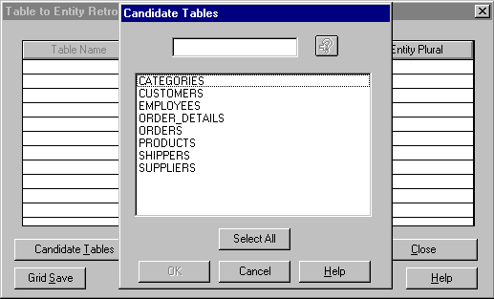
(fig 9)

- Click on Select All and click the Retrofit button (fig 9) to begin the process of retro-fitting the tables to entities.
- When the utility has completed click the Close button and close down the utility (fig 9).
- From the menu inside the Entity Relationship Diagrammer select ‘File/New’, this will bring up a new Entity Relationship Diagram.
- From the menu inside the Entity Relationship Diagrammer select ‘Edit/Include/Entity’, here you will see the entities we retro-fitted, press the Select All button and hit OK.
- By checking the ‘With Relationships’ checkbox any relationships that exist will be brought into the diagram (fig 10).

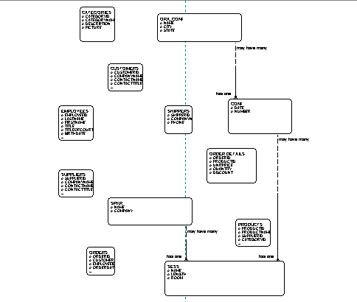
(fig 10)

The appearance of the elements (fig 11) on a new diagram can be altered by changing the graphical preferences for either selected elements, or all elements of a specified element type. You can also define whether you want to show or hide the properties of elements on a diagram.

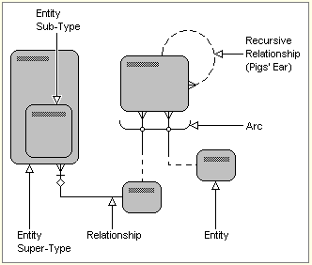
(fig 11)

Summary

Now that you have created an Entity Relationship Diagram consisting of the database you reversed engineered you can now store and manipulate information. An essential part of developing a system is constructing an accurate model of the information needs of an organization. The Entity Relationship Diagrammer enables you to create an information model in the form of a diagram showing the elements of information and the way they are logically related. The information model will act as a framework for the development of new or enhanced systems.
For wide-scale developments, an information model can be drawn showing the data used throughout a business. An "enterprise-wide data model" is commonly used by large organizations to help them establish strategic plans for their information systems. You can use the Entity Relationship Diagrammer to define logical data warehouse models. Each entity must be identified as either a fact or a dimension.

About the Author

Mark Falvo is a Senior Software Engineer for Computer Resource Team, Inc. in Richmond, Virginia. He has more than 5 years experience in design and developing Oracle client/server applications as well as web based applications. He has application experience in hotel industry, state government, and food manufacturing.

