Generating a WebForm using Designer 6 : less than an hour
Mark Falvo, Computer Resource Team, Inc
Introduction

This paper covers how to generate a WebForm using Designer 6 in a three-tier architecture. I will be covering the following : how a three-tier application differs from the traditional two-tier application, what a WebForm actually is and how it differs from a Developer Form, steps required in building a Form from Designer and how a WebForm using Designer fits into a three-tier application. Finally, I will cover some of the new enhancements in Designer 6i. I will not be covering the steps required in setting up the Oracle Application Server, nor will I cover how to setup an Oracle Repository. For this presentation I will be using Oracle Designer 6.0.3.8.0, Oracle Application Server 4.0.8.1.0, and the Oracle Enterprise Edition Release 8.1.6.0.0 database, and Netscape 4.7.2 on Windows NT 4.0 service pack 5.

Two-Tier application overview

Traditionally Oracle Form applications are run in a client-server platform (Fig 1) where each client machine holds a copy of the application code. In this two-tiered architecture, each client machine has to install a Forms runtime engine. Each client machine is also responsible for all form functionality (UI interaction, trigger and commit processing, record management, and general database interaction). The major drawback here is as the application becomes more complex, the size of the application increases. As the size of the application increases, the client hardware platform must also increase in terms of power and memory. Because of this, the server platform must also increase in capacity.

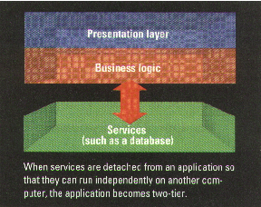
(fig 1)

Three-Tier application overview

More and more Oracle Form applications are run in a three-tiered application (Fig 2). The front-end tier, which is the client machine, requires only a web browser. The client hardware doesn’t require much power or memory; this work is now offloaded to the application server. The middle-tier, which is the application server, holds only one copy of the application code. This allows an application be deployed worldwide with all the source code on one application server. The middle-tier must be powerful enough to handle this though. When the client machine runs a WebForm, a Forms Client is downloaded from the application server to a client machine as a java applet displayed in the user's Web browser. This piece is called the Forms Cartridge, and this is Oracle specific so you could run this on another type of application server. The application server communicates to the database for the client. This takes all responsibilities away from the client server in communicating to the back-end tier, which is the database server. For the setup I’m using, the web browser can be Internet Explorer 5.0 or Netscape 4.5.1 and higher.

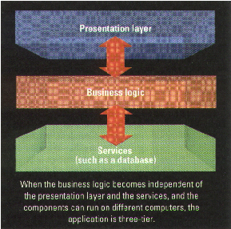
(fig 2)

What is a WebForm and how does it differ from Developer Forms ?

- The term WebForm is used to describe a Developer Form Builder application running in a three-tier application.
- When you generate a Form module out of Designer, the Developer Form Compiler is invoked to generate a .fmb file and a .fmx file.
- Designer can generate anything Developer Forms can generate if you have appropriate experience using Designer. The learning curve for Designer is substantially higher than that of Developer.
- Developer is a more powerful tool when it comes to making customizations in the layout, or quick and dirty changes, changes that could easily take hours generating and regenerating in Designer.
- The difference is Designer keeps all the information about the module in the repository, which resides in the database.
- Developer Form Builder can either store its information in the database under its own schema or as a physical .fmb file and .fmx file which is stored on a shared drive or local drive.

4 steps required to create a WebForm

Before creating a module, it is imperative to get input from end users on how the look and functionality of the Form should work well before any work is done past the data model. A template Form is imperative in getting the most out of your generated Form, yet it is time consuming. This is a Developer Form that has the common objects including menus, attached libraries, alerts, common logic, and so on. The template form is where we generate our objects from Designer to.
I will be using the following server data model (fig 3):

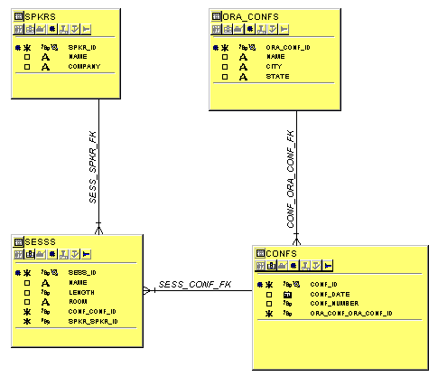
(fig 3)

- Create a Functional Hierarchy Diagram

It is not required that you start here; you can start at step 3 and create a module manually. A Functional Hierarchy Diagram takes entity usages that you define and saves these as functions. The Application Design Transformer takes these functions and generates modules; the module will become our Form. To use this tool properly you have to know what you want created in full. This is where it is important to get a finalized detailed design of a Form before you continue past the entity module diagrammer. If you create a module and decide to add or delete objects and come back to this point and modify your function, the generated module will be overwritten. One alternative to this is to version the module (10,20, etc). For this presentation we’re going to create one function. You can also use the Functional Hierarchy Diagrammer to define functions, call other functions and create menus.

- From the front panel (fig 4) select the Functional Hierarchy Diagrammer icon.
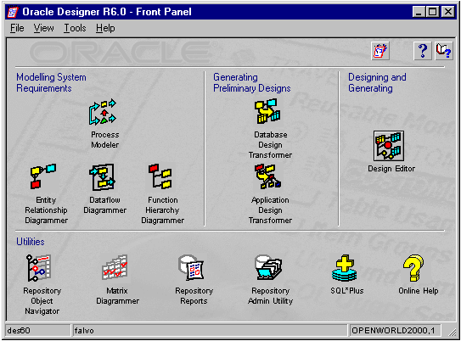
(fig 4)

- Once the Functional Hierarchy Diagrammer has opened, select file/new, then select ‘new function’; type in a label ‘FHD’ and a short definition ‘OpenWorld Function # 1’ (both are required).
- Double click inside the function we created and you’ll see the following (fig 5) :

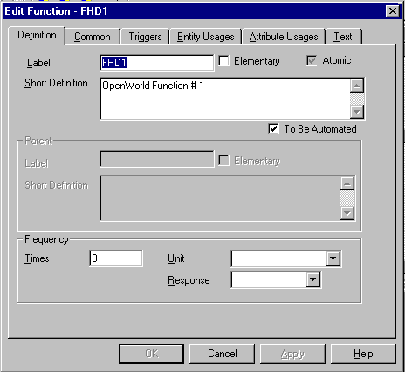
(fig 5)

- Highlight the entity usages tab and select CONFERENCE from the drop down list, then check: create, retrieve, update, and delete. On the second line, select SESSION from the drop down with same options. The function represents meta data at this point.
- Highlight the attribute usages tab and click on the ‘Select All’ button. (this pulls in all columns with the functionality you checked off on the entity usages tab).
- Click ‘Apply’ then ‘OK’.
- Select ‘file/save diagram as’ and type in OPENWORLD.
- Close the Functional Hierarchy Diagrammer.

- Run the Application Design Transformer

The Application Transformer takes the function we just created in the Functional Hierarchy Diagrammer and generates a module that represents the server model taking all the functionality we defined from our meta data (our entities).
From the front panel click on the Application Design Transformer icon.
- When the window opens you’ll see the following (fig 6):

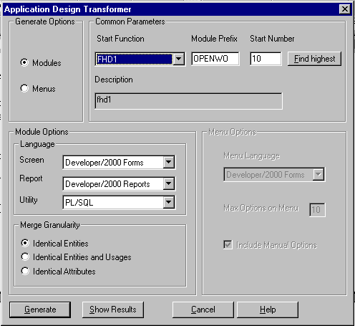
(fig 6)

- Set the generate options to ‘Module’.
- Select the start function ‘OPENWO’ (only the fist 6 letters are captured).
- Leave all other options defaulted (the start number is a way to version generated functions mentioned earlier).
- Click the generate button. (When the transformer is completed there will be a button labeled ‘Close’, click this when it appears, you will be then placed back at the front panel).

- Completing the module design in the Design Editor

From the front panel click on the Design Editor icon to complete work on the module and select the module tab.
- Highlight the module OPENWO0010 that we just created and expand it down to the module component level (fig 7). You should see CONFERENCES and SESSIONS (the module components now directly relate to the server model relational table definition within the repository, not the meta data (entities).

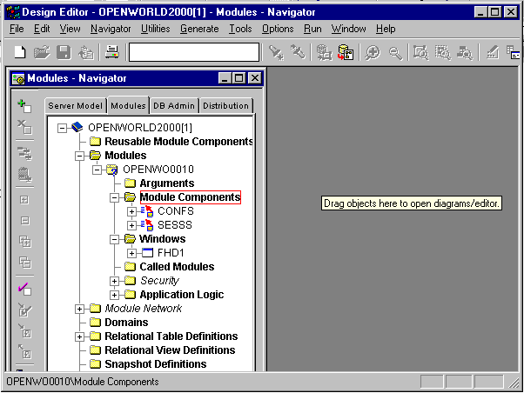
(fig 7)

- With CONFS highlighted select from the menu ‘Tools/Module Component Display Wizard’ (fig 8) complete steps (c) through (j).
- Enter in the number of rows and overflow style if necessary.
- Select displayed items if necessary.
- Change item detail if necessary.
- Enter item groups if necessary.
- Rearrange ordering and specify the items for each item group if necessary.
- Specify placement, exit wizard.
- With CONFS still highlighted expand tree down to Table Usages’ and right-click on CONFS and select ‘Create Module Component Table Wizard’.
- Select ‘ORA_CONFS’, follow wizard selecting all columns to display and click on ‘Finish’ button.

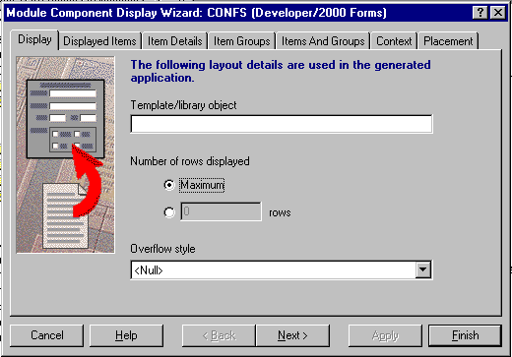
(fig 8)

- Repeat steps (b) through (j) for module component SESS, in step (i) and (j) use the lookup table SPEAKERS, again follow wizard selecting all columns to display and click on ‘Finish’ button.
- Now that both module components are defined, highlight the module OPENWORLD and right click on it, select ‘Show On New Diagram’ (fig 9). This will show you the data diagram; here you can edit any information you like relating to the data by simply double-clicking inside any object.

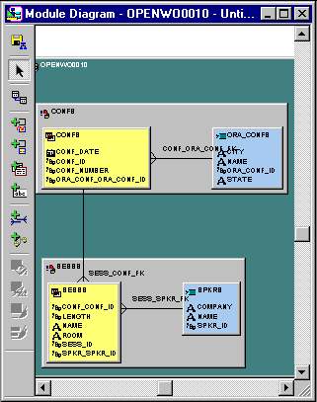
(fig 9)

- Click on the icon to switch the view to the display view (fig 10). Here you’ll see the module components we created from a display point of view. Again here you can edit any information you like relating to the display by simply double-clicking inside any object.

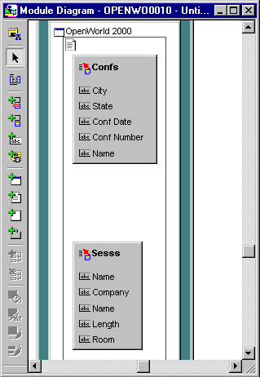
(fig 10)

- From the menu choose ‘Edit/Generator Preferences’ (fig 11) to see the generator preferences that are available, have the module navigator window next to the preferences window. Notice how the generator preferences window changes depending on what you select in the module navigator, only certain properties are available for certain objets. One important property section is the ‘Standards’, here you can designate a template form, object libraries, and other properties.

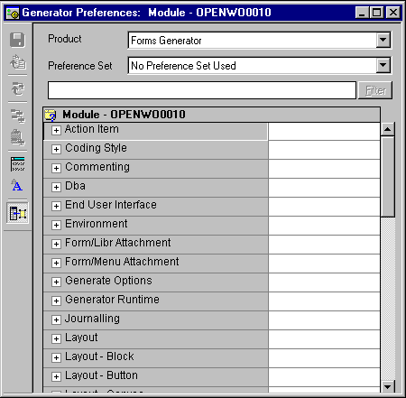
(fig 11)

- Generation Time !

- Now that we have defined our module, we can generate it. From the menu choose ‘Generate/Generate Module’ (fig 12). Designing and modifying the modules is a long process; all we did here was create a simple form. During generation this is where Developer Forms Compiler is invoked from Designer to generate a .fmb and .fmx file.

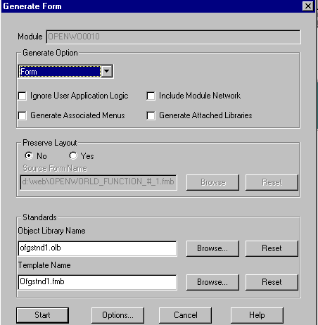
(fig 12)

- Click on the ‘Start’ button, you’ll see a Message Window come up with messages. If it was successful, you’ll only see blue messages with an option at the end to save the module; otherwise, you’ll get a red message signaling an error has occurred.

Below is one screen shot from the Oracle Application Server (fig 13), showing the virtual directory setup.
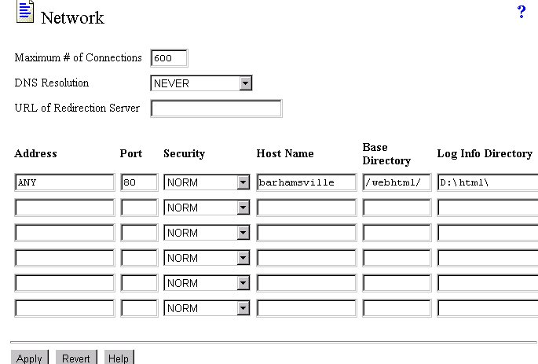
Summary

From here type in your URL (http://barhamsville/html_page.html - this will depend on your Oracle Application Server setup) in either Netscape or Internet Explorer. From figure 13 the .fmx we generated would reside in the ‘Log Info Directory’ for example. At this point the Oracle Application Server will run the Form we just created as a WebForm from within your browser.
To create a complicated form could take a week or more depending on the required coding. What I wanted to show here was the overall process of generating a very simple WebForm. I think Designer is not used often or it is not used to its fullest capacity because many companies are afraid of using Designer simply because a person can be 60 – 70 % into a project and there is nothing to show. Designer is expensive in terms of time in the designing and building of a Form. In the long run it is much cheaper using Designer than building Forms and Reports manually in Developer because what has been built in Designer, if built properly, can be modified to fit the businesses’ needs in the future with great ease. It is also very important to spend the time on a template Form because if a Form is generated on a well thought out template post generation work is cut substantially.
I think the worst thing a business could do is let an end user ‘mock’ up screen designs and then expect them to be created in Designer. It is not impossible, but it makes more sense to have the developer who is designing the Forms in Designer have input on what is cost effective and what is not, or at least let management make that decision before any design is performed.

About the Author

Mark Falvo is a Senior Software Engineer for Computer Resource Team, Inc. in Richmond, Virginia. He has more than 5 years experience in design and developing Oracle client/server applications as well as web based applications. He has application experience in hotel industry, state government, and food manufacturing.

